Algebra 2 HW #7 FACTORING & OTHER ALG 1 TOPICS WS Name ____________________________________ Period _____
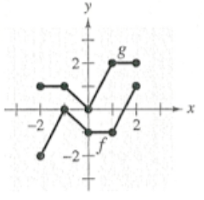
1. Given the graph of f and g, state the following:
a) Is the graph f a function? Explain. c) Is the graph g a function? Explain.

b) Domain and range for graph f. d) Domain and range for graph g.
Domain Range Domain Range
Interval Interval
Inequality Inequality

____________________________________________________________________________________________________________________________
2. Factor each polynomial.
a) x² - 8x - 20 b) 2x² + 16x + 32 c) 4x² – 11x + 7

____________________________________________________________________________________________________________________________
3. Solve each equation by factoring.
a) x² + 5x - 36 = 0 b) 2x² + 8x – 24 = 0 c) 3x² – 16x + 5 = 0

____________________________________________________________________________________________________________________________
4. Solve the system of equations using a method of your choice.
a) y = 6x - 11 b) -4x – 2y = -12 c) x – 2y = 15
-2x – 3y = -7 4x + 8y = -24 2x + 3y = 2

