PRACTICE, PRACTICE, PRACTICE!

Domain and Range Practice
For each of the following graphs determine the Domain and Range. Use BOTH interval notation as well as inequality notation.
#1 D: #2 D: #3 D:

R: R: R:

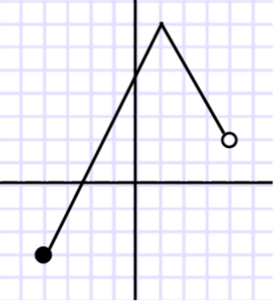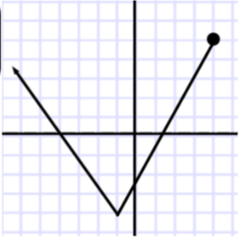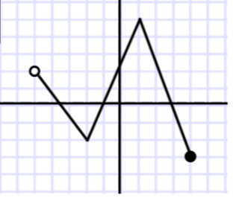
------------------------------------------------------------------------------------------------------------------------------------------------------------------------
Evaluating Functions Practice

x | f(x)
-3 | 1
-2 | -2
-1 | 2
0 | -2
1 | 1

#4 Examine the graphs of f(x) and #5 Refer to the table below. #6 Given g(x) = x² – x, find the value of each
g(x) below. Use the graph to expression below.
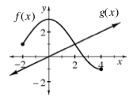
approximate the values below.
a) g(-1) b) x if g(x) = 12

a) Find f(-1). ________

a) f(0) = ____ b) g(4) = ____ b) Find x when f(x) = -2.

c) Find x when g(x) = 1. x = ____ _________________

------------------------------------------------------------------------------------------------------------------------------------------------------------------------
Solving Equations by Factoring Practice
Use the Zero Product Property and factoring, when necessary, to solve for x.
#7 (x + 1)(x + 2) = 0 #8 x² – 9x + 14 = 0 #9 4x² + 9x + 5 = 0 #10 7x² – 13x – 2 = 0

